> **ecdif:=diff(x(t),t$2)+(w0^2)*x(t);**



> **sol:=dsolve(ecdif,x(t));**



> **x1:=unapply(rhs(sol),t,_C1,_C2);**



> **x2:=x1(t,R*cos(phi),R*sin(phi));**



> **sol3:=x(t)=combine(x2);**



> **x3:=unapply(x1(t,R*cos(phi),R*sin(phi)),t);**



> **cond_in:=x3(0)=x0,D(x3)(0)=v0;**



> **sol1:=solve({cond_in[1],cond_in[2]},{R,phi});**



> **sol2:=allvalues(sol1);**



> **R1:=unapply(rhs(sol2[1,1]),w0,x0,v0);**



> **P1:=unapply(rhs(sol2[1,2]),w0,x0,v0);**



> **R2:=R1(sqrt(5),2,3);**



> **P2:=P1(sqrt(5),2,3);**



> **x4:=unapply(rhs(sol3),t,R,phi,w0);**



> **with (DEtools); with(plots);**



Warning, the name changecoords has been redefined



> **plot([x4(t,R2,P2,sqrt(5))],t=-2*Pi..2*Pi);**

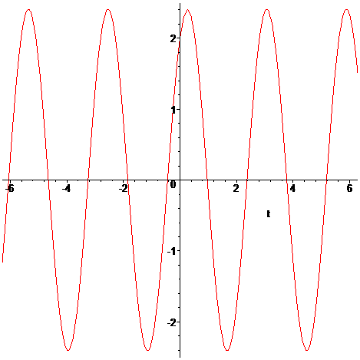

> **R3:=R1(3,7,5);**



> **P3:=P1(3,7,5);**



> **plot([x4(t,R3,P3,sqrt(5))],t=-2*Pi..2*Pi);**

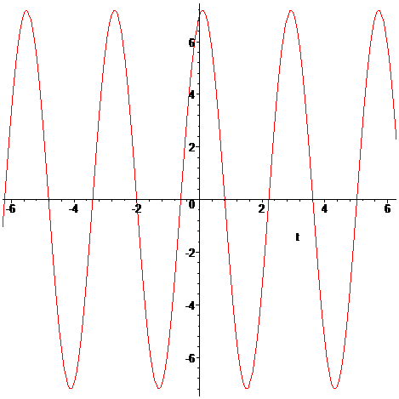

> **ecdif1:=diff(x(t),t$2)+lambda*diff(x(t),t)+(w0)^2*x(t)=0;**

